**BKM to Enable PyDev in Simics**

**Fig 1:**

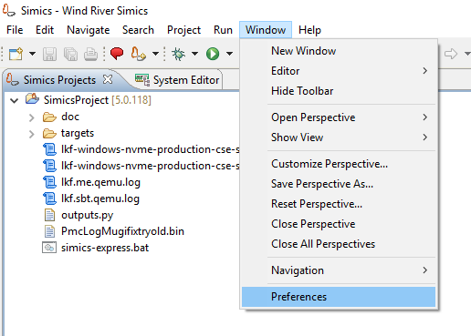

**Fig2:**

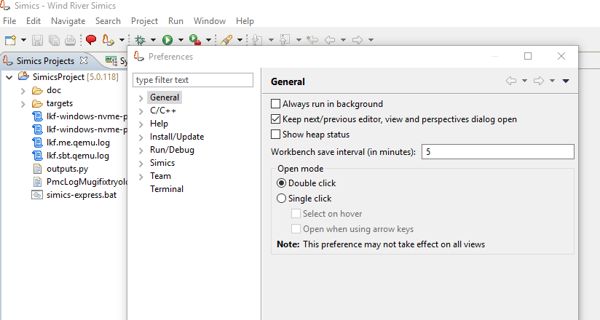

By Default with latest Simics, PyDev will not integrated automatically. We have to manually integrate.

**Fig 3:**

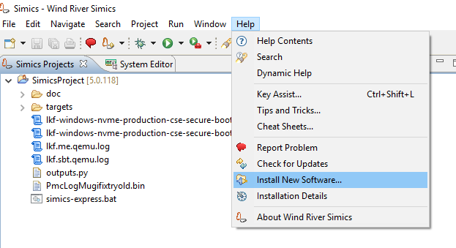

**Fig 4:**

Provide this paths <http://www.pydev.org/update_sites/4.5.5/>

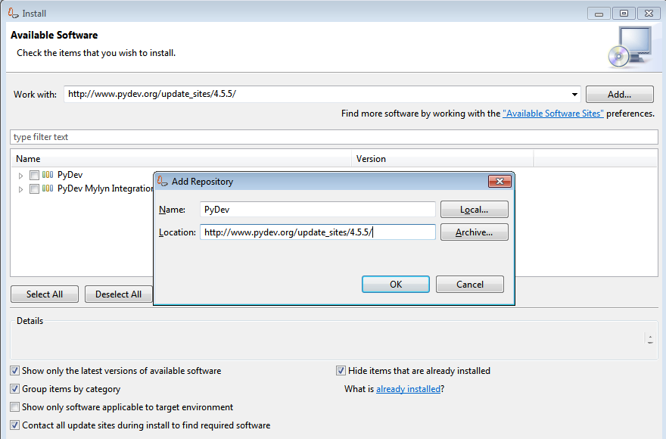

**Fig 5:**

Once Press Ok, it start fetching PyDev from the repository. Intel Nework won’t allow you to download fully. Will end up with Fig 6. Need to configure the proxy proerly for the Intel Geo.



**Fig 6:**

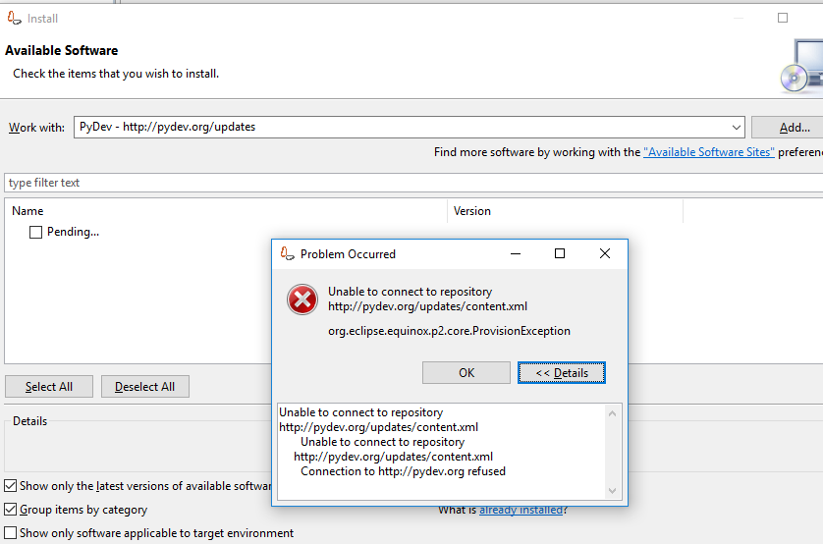

**Fig 7:**

Windows 🡪 Preferences, type network, you will see Network Connection, have to configure proxy for HTTP, HTTPS here. By default Active Provider is Native. Change it to manual & provide the proxy host & port for current Geo. Then press ok.

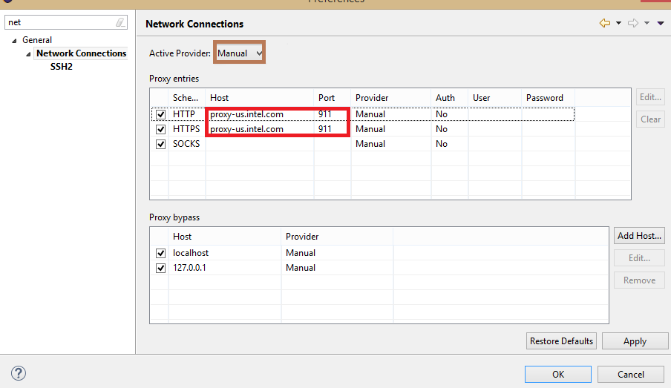

**Fig 8**

Now Help 🡪 Install new software. You will able to download PyDev. Follow next & finsh download.

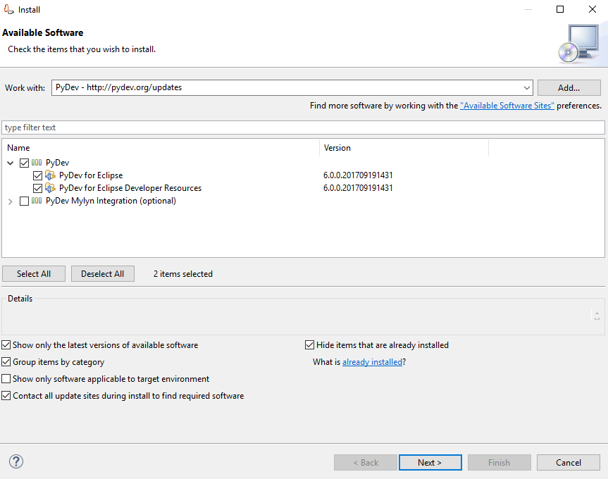

**Fig 9**

Select PyDev alone & install 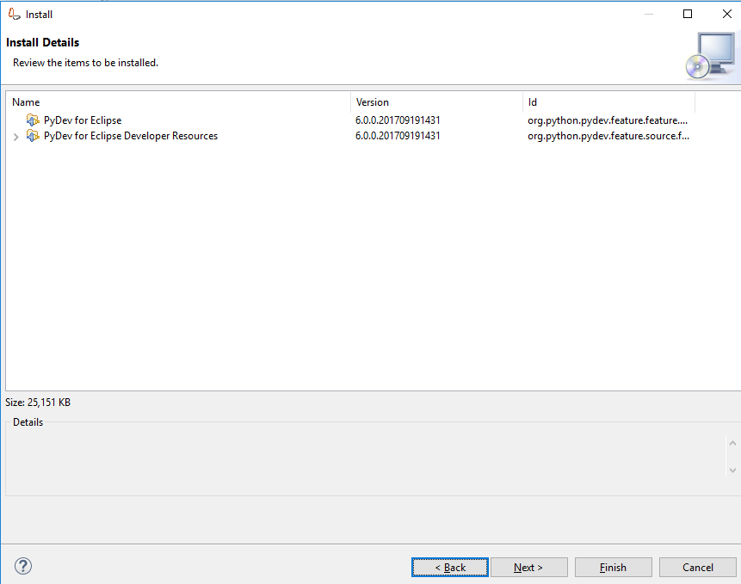

Fig 10

Then finish.

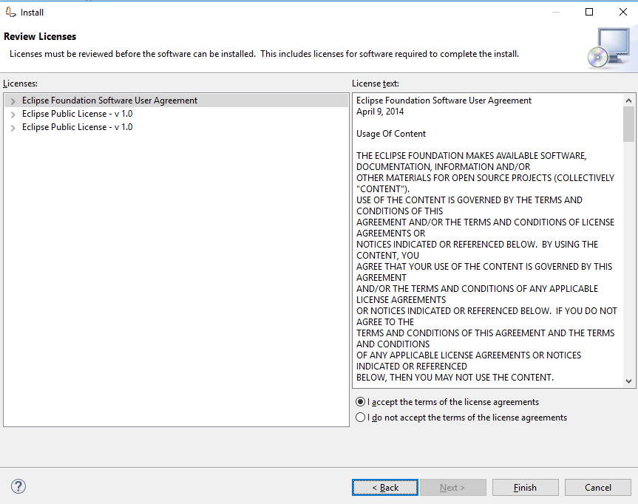

Fig 11:

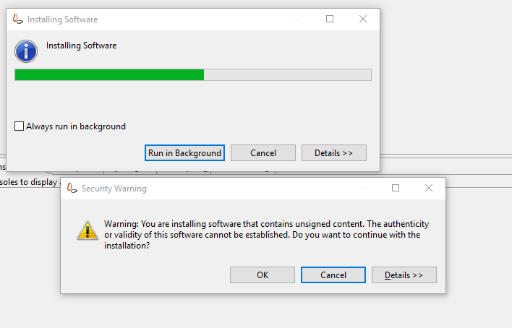

Follow instructions & finish installtion. Need to restart the simics eclipse. Once you restart the simics eclipse, we will able to see PyDev in Preference window.

**Fig 12:**

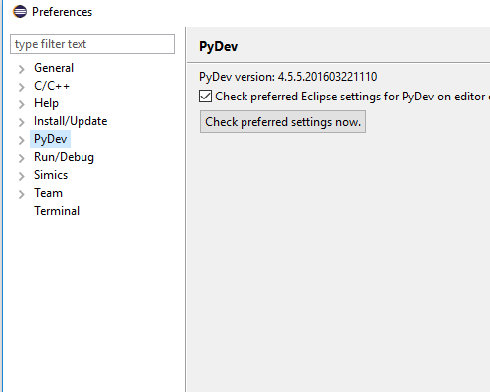

**More info:**

Steps on <http://www.pydev.org/manual_101_install.html>

BKM To enable ITP on simics

After you enable Pydev using the above BKM, or assuming you have PyDev on your system,

goto “Window->Preferences”

**Fig 13:**

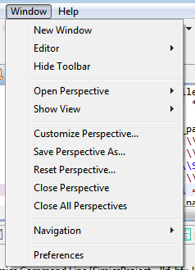

In Preferences Window click on “PyDev->Python Interpreter” and then on “New” tab

Click on Browse and select “C:\Python27\Python.exe” and hit OK, OK.

**Fig 14:**

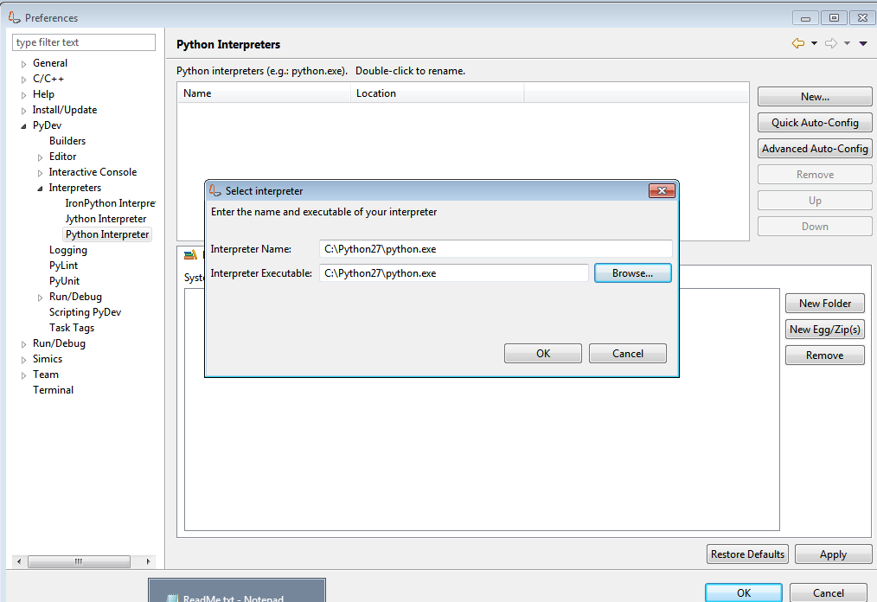

Click on “New Folder” Tab and select following folder and Hit “OK”, this will add the Scripts path to the interpretor, for you to be able to import ITP and related scripts.

“C:\Program Files\Simics\Simics 5\eclipseuefi 5.0.58\scripts”

**Fig 15:**

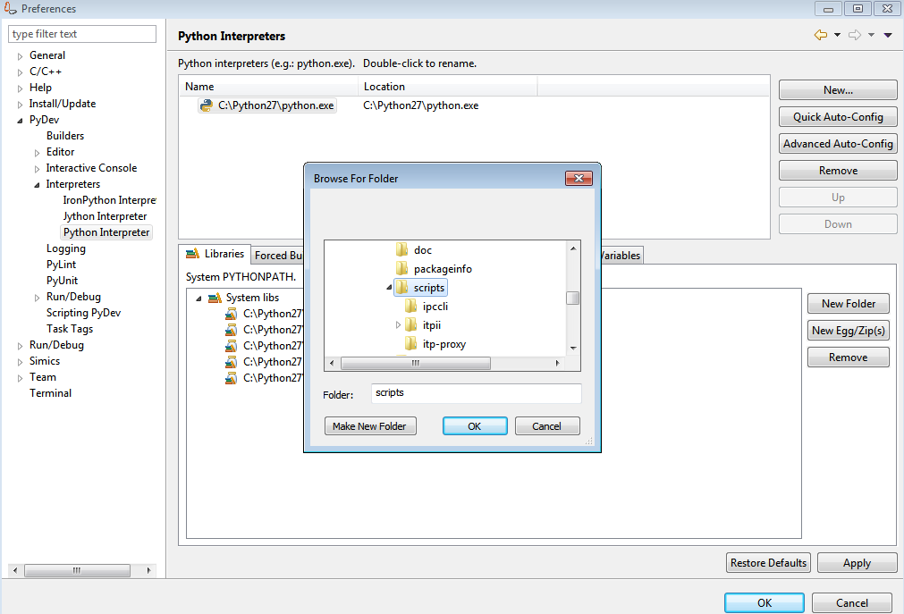

In “Window->Preferences” click on “PyDev->Interactive Console->Initial Commands” and have following entries under “PyDev interactive console initial commands”

import sys

import itpii

itp=itpii.baseaccess()

**Fig 16:**

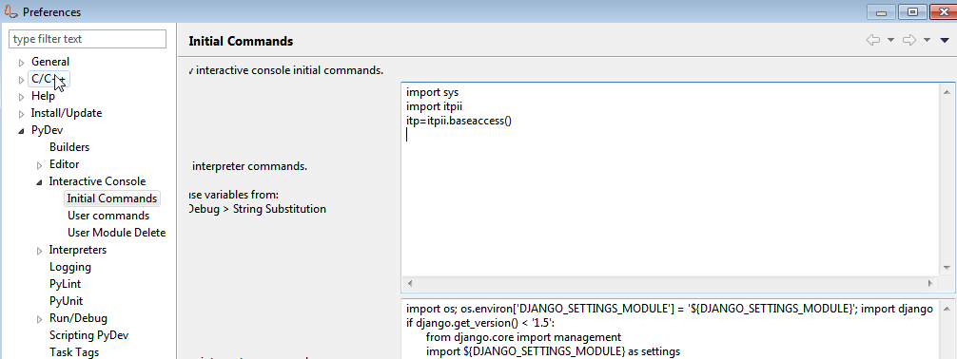

To open ITPii console or python prompt please start the Simics session and then in “Console” Tab click on “Open Console->PyDev Console” and then Click “OK”

**Fig 17:**

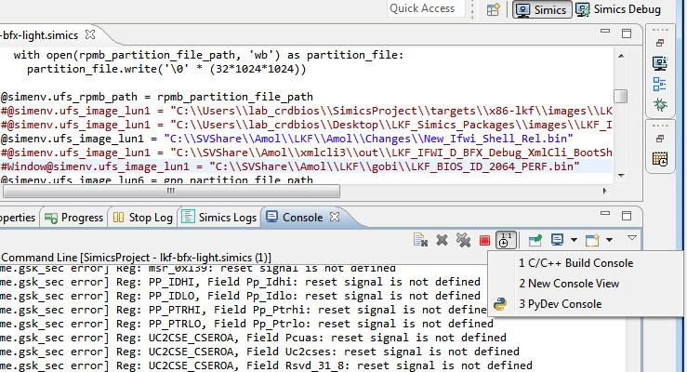

The above will open Python Prompt with the itp support enabled, and you can run your itp commands here. Please note it will run the commands mentioned in the “initial commands tab” in Fig 16

**Fig 18:**

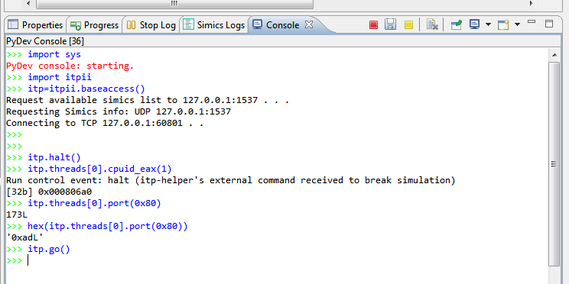

**Steps to enable Xmlcli online commands on Simics**

After Enabling ITPii on Simics and opening the Python prompt in Simics as shown above, the user simply needs to import XmlCli scripts, set “itpsimics” as interface mode, and run them on the Python prompt as any other usual itpii interface, see below figures for reference.

You can find the latest XmlCli reference scripts under \\bascrd101\svshare\amol\XmlCliRefScripts\

Latest drop as of now is \\bascrd101\svshare\amol\XmlCliRefScripts\xmlcli_Rev0.9.zip

